|  |  |
| --- | --- |
|  |  |
| 2-D Feed Backward Predictive Coding |  |
|  |  |
|  | DSAI 325Information Theory |
|  | Mohamed Ehab Yousri202201236 |

**2-D Feed Backward Predictive Coding**

### ****Introduction****

This report presents the implementation of a 2D Feed Backward Predictive Coding (DPCM) algorithm in Java for image compression. Predictive coding is a powerful technique for compressing grayscale images by predicting each pixel value based on previously encountered pixels. This method efficiently reduces image size by encoding the residual error (the difference between the predicted and actual pixel value) and quantizing it.

### ****Objectives****

The main objectives of this assignment are:

**-Implementation of DPCM**: We implemented the DPCM algorithm to compress grayscale images using different predictors (Order-1, Order-2, and Adaptive 2-D).

**-Quantization Levels**: The effect of varying quantization levels (8, 16, 32) on compression and image quality was analyzed.

**-Compression Evaluation**: We aimed to evaluate the quality of reconstruction using Mean Squared Error (MSE) and analyze the compression ratio for different predictors and quantization levels.

### ****Methodology****

The process of image compression and reconstruction is divided into the following main stages:

#### **Preprocessing:**

The input image is read, converted to grayscale (if not already in grayscale), and stored as a 2D array representing the pixel values.

**Predictive Coding (Encoding):**

The encoding process predicts each pixel’s value based on previously processed pixels.

The three predictor types used are:

**-Order-1**: Uses the left pixel as the predictor.

-**Order-2**: Uses the left and upper pixels, accounting for the previous row and column.

**-Adaptive 2-D Predictor**: Adapts based on the minimum and maximum of surrounding pixels.

The residual error (difference between predicted and actual pixel value) is calculated, and the residuals are quantified using uniform scalar quantization.

#### **Decoding:**

Decoding reconstructs the image from the quantized residuals by applying the same predictor used in encoding.

#### **Evaluation**

**-Mean Squared Error (MSE)**: Measures the difference between the original and reconstructed images. It is computed pixel by pixel and averaged over the whole image.

-**Compression Ratio**: The ratio of the original image size to the compressed image size, which reflects the effectiveness of the compression algorithm.

**Implementation Details:**

**Code Structure:**

The project was divided into the following classes:

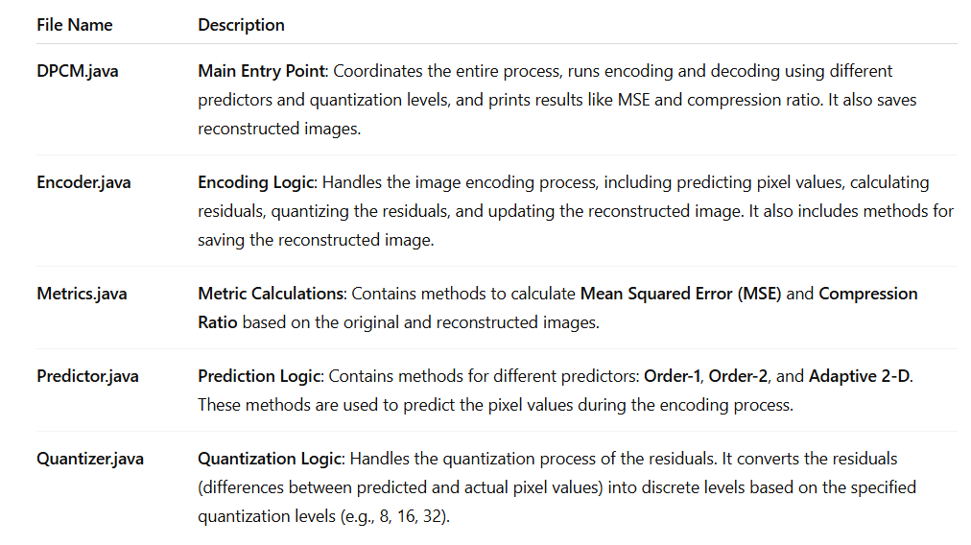

**reconstructed_images**: This folder stores all the output images after reconstruction. Images are saved in this folder with names indicating the predictor and quantization level used.

#### **Quantization**

Quantization is a process of mapping a large set of input values to a smaller set. The residuals (differences between predicted and actual pixel values) are quantized into discrete levels. We used a range of quantization levels (8, 16, 32) to see the impact on both compression and image quality. The higher the quantization level, the finer the resolution of the residuals, leading to better image quality but at the cost of compression efficiency.

Prediction Mechanisms

**1-Order-1 Predictor:** The value of the current pixel is predicted based on the value of the pixel to its left (previous pixel in the same row).

Formula:

**2-Order-2 Predictor**: The value is predicted based on the left pixel and the pixel directly above it (previous row and column).

Formula:



3-**Adaptive 2-D Predictor**: This predictor adapts based on the minimum and maximum of the adjacent pixels, providing more flexibility to account for varying patterns in the image.

Formula:

Compression Ratio and MSE

The **Compression Ratio** is calculated as the ratio of the original image size to the encoded image size, while **MSE** measures the accuracy of the reconstructed image.

**Results and Discussion:**

The Original Image:

Test Cases:

Order-1 Predictor Results:

**Order-1 Predictor | Quantization Level: 8:**

-MSE: 1281.15

-Compression Ratio: 2.67

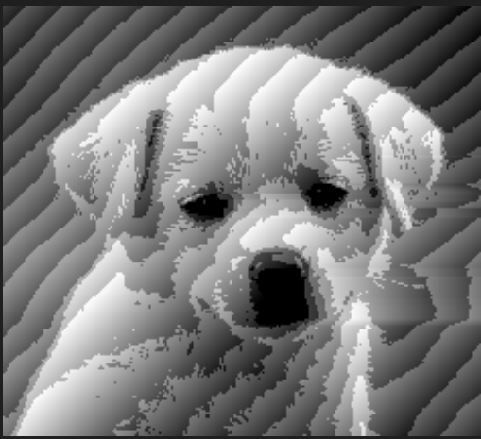

**Order-1 Predictor | Quantization Level: 16:**

-MSE: 301.53

-Compression Ratio: 2.00

**Order-1 Predictor | Quantization Level: 32:**

-MSE: 64.79

-Compression Ratio: 1.60

**Order-2 Predictor Results**:

**Order-2 Predictor | Quantization Level: 8:**

-MSE: 1277.93

-Compression Ratio: 2.67

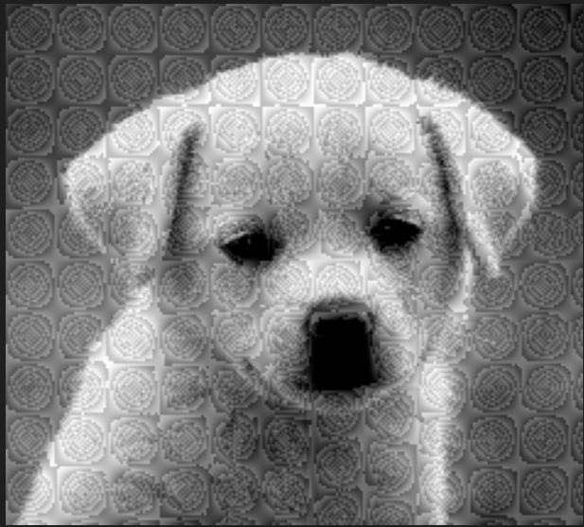

**Order-2 Predictor | Quantization Level: 16:**

-MSE: 302.15

-Compression Ratio: 2.00

**Order-2 Predictor | Quantization Level: 32**

-MSE: 63.23

-Compression Ratio: 1.60

Adaptive Predictor Results:

**Adaptive Predictor | Quantization Level: 8**

-MSE: 1244.13

-Compression Ratio: 2.67

**Adaptive Predictor | Quantization Level: 16**

-MSE: 308.54

-Compression Ratio: 2.00

**Adaptive Predictor | Quantization Level: 32**

-MSE: 65.36

-Compression Ratio: 1.60

So:

Test Case Results

Impact of Quantization Levels on MSE and Compression Ratio:

- **MSE** decreases as the quantization level increases, indicating that higher quantization levels provide better image reconstruction quality, as they can represent more detail in the residuals.

-**Compression Ratio** decreases as the quantization level increases, which is expected because higher quantization levels produce larger residual values and require more bits for storage.

Image Visual Quality:

The images reconstructed with higher quantization levels (32 levels) appear sharper and closer to the original, though they take up more storage space. Images reconstructed with lower quantization levels (8 levels) show more blackness and compression artifacts.

**Conclusion**

The DPCM algorithm was successfully implemented in Java for grayscale image compression. Three different predictors were compared, and the impact of quantization levels on compression performance and image quality was analyzed. As expected, higher quantization levels resulted in better image quality but at the expense of compression efficiency. The Adaptive 2-D Predictor produced the best results, particularly in terms of visual quality and MSE.